A language learning Center Project

* **Introduction :**

The idea of ​​the project is a language learning center that contains three languages: English, Turkish, and French. It allows the user to choose the language he wants, and by asking him for personal information such as his name, phone number, and age, and then adding this information to the language file that the user chose.

* **About The Program :**

It includes read and write from a file , multiple data structures such that loops , and the most

important thing the GUI interface .

1. 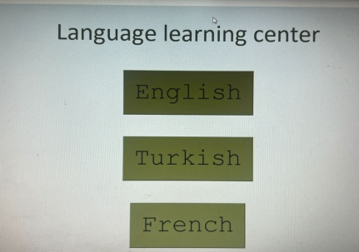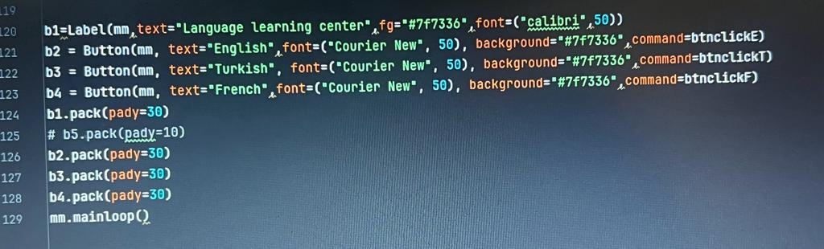Firstly the first screen will be shown to the user which include three main buttons (English , Turkish and french ) .

Each button is linked with a def using the attribute “command” , and each def contains a process that the program should do when the user click on it ,

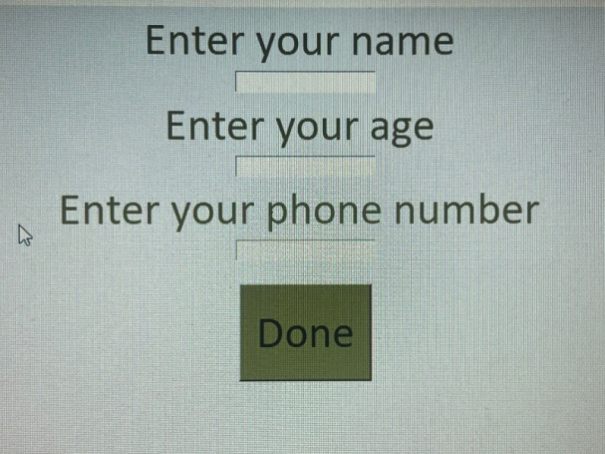If he/she click on the “english “ or “turkish” or ”french”.

the second page will be

Ask the person some of personal information such as : name ,age and phone number.

And here is the code of English :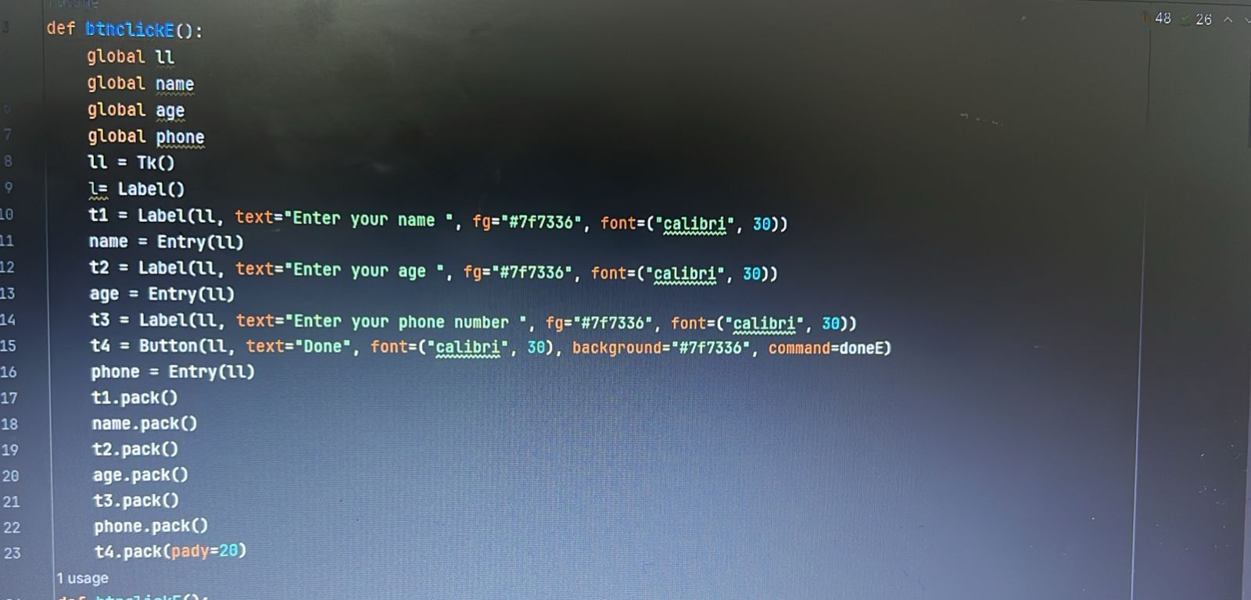

The last screen will be shown   
The user's information appears in the file of the language he chose

